# WEEK 2 ADVANCED SQL (FUNCTIONS)

THE CODE:

DROP TABLE IF EXISTS Employees;

DROP TABLE IF EXISTS Departments;

CREATE TABLE Departments (

DepartmentID INT PRIMARY KEY,

DepartmentName VARCHAR(100)

);

CREATE TABLE Employees (

EmployeeID INT PRIMARY KEY,

FirstName VARCHAR(50),

LastName VARCHAR(50),

DepartmentID INT,

Salary DECIMAL(10, 2),

JoinDate DATE,

FOREIGN KEY (DepartmentID) REFERENCES Departments(DepartmentID)

);

INSERT INTO Departments (DepartmentID, DepartmentName) VALUES

(1, 'HR'),

(2, 'IT'),

(3, 'Finance');

INSERT INTO Employees (EmployeeID, FirstName, LastName, DepartmentID, Salary, JoinDate) VALUES

(1, 'John', 'Doe', 1, 5000.00, '2020-01-15'),

(2, 'Jane', 'Smith', 2, 6000.00, '2019-03-22'),

(3, 'Bob', 'Johnson', 3, 5500.00, '2021-07-01');

DROP FUNCTION IF EXISTS fn_CalculateAnnualSalary;

GO

CREATE FUNCTION fn_CalculateAnnualSalary

(

@MonthlySalary DECIMAL(10,2)

)

RETURNS DECIMAL(10,2)

AS

BEGIN

RETURN @MonthlySalary * 12;

END;

GO

SELECT

EmployeeID,

FirstName,

LastName,

Salary AS MonthlySalary,

dbo.fn_CalculateAnnualSalary(Salary) AS AnnualSalary

FROM Employees;

DROP FUNCTION IF EXISTS fn_GetEmployeesByDepartment;

GO

CREATE FUNCTION fn_GetEmployeesByDepartment

(

@DeptID INT

)

RETURNS TABLE

AS

RETURN

(

SELECT

EmployeeID,

FirstName,

LastName,

DepartmentID,

Salary,

JoinDate

FROM Employees

WHERE DepartmentID = @DeptID

);

GO

SELECT * FROM fn_GetEmployeesByDepartment(2);

DROP FUNCTION IF EXISTS fn_CalculateBonus;

GO

CREATE FUNCTION fn_CalculateBonus

(

@Salary DECIMAL(10,2)

)

RETURNS DECIMAL(10,2)

AS

BEGIN

RETURN @Salary * 0.10;

END;

GO

SELECT

EmployeeID,

FirstName,

LastName,

Salary,

dbo.fn_CalculateBonus(Salary) AS Bonus

FROM Employees;

DROP FUNCTION IF EXISTS fn_CalculateBonus;

GO

CREATE FUNCTION fn_CalculateBonus

(

@Salary DECIMAL(10,2)

)

RETURNS DECIMAL(10,2)

AS

BEGIN

RETURN @Salary * 0.15;

END;

GO

SELECT

EmployeeID,

FirstName,

LastName,

Salary,

dbo.fn_CalculateBonus(Salary) AS UpdatedBonus

FROM Employees;

SELECT

EmployeeID,

FirstName,

LastName,

Salary AS MonthlySalary,

dbo.fn_CalculateAnnualSalary(Salary) AS AnnualSalary

FROM Employees;

SELECT dbo.fn_CalculateAnnualSalary(Salary) AS AnnualSalary

FROM Employees

WHERE EmployeeID = 1;

DROP FUNCTION IF EXISTS fn_GetEmployeesByDepartment;

GO

CREATE FUNCTION fn_GetEmployeesByDepartment

(

@DeptID INT

)

RETURNS TABLE

AS

RETURN

(

SELECT

EmployeeID, FirstName, LastName, DepartmentID, Salary, JoinDate

FROM Employees

WHERE DepartmentID = @DeptID

);

GO

SELECT * FROM fn_GetEmployeesByDepartment(3);

DROP FUNCTION IF EXISTS fn_CalculateAnnualSalary;

GO

CREATE FUNCTION fn_CalculateAnnualSalary(@Salary DECIMAL(10,2))

RETURNS DECIMAL(10,2)

AS

BEGIN

RETURN @Salary * 12;

END;

GO

DROP FUNCTION IF EXISTS fn_CalculateBonus;

GO

CREATE FUNCTION fn_CalculateBonus(@Salary DECIMAL(10,2))

RETURNS DECIMAL(10,2)

AS

BEGIN

RETURN @Salary * 0.15;

END;

GO

DROP FUNCTION IF EXISTS fn_CalculateTotalCompensation;

GO

CREATE FUNCTION fn_CalculateTotalCompensation(@Salary DECIMAL(10,2))

RETURNS DECIMAL(10,2)

AS

BEGIN

RETURN dbo.fn_CalculateAnnualSalary(@Salary) + dbo.fn_CalculateBonus(@Salary);

END;

GO

SELECT

EmployeeID,

FirstName,

LastName,

Salary,

dbo.fn_CalculateTotalCompensation(Salary) AS TotalCompensation

FROM Employees;

DROP FUNCTION IF EXISTS fn_CalculateBonus;

GO

CREATE FUNCTION fn_CalculateBonus(@Salary DECIMAL(10,2))

RETURNS DECIMAL(10,2)

AS

BEGIN

RETURN @Salary * 0.20;

END;

GO

SELECT

EmployeeID,

FirstName,

LastName,

Salary,

dbo.fn_CalculateTotalCompensation(Salary) AS UpdatedTotalCompensation

FROM Employees;

THE OUTPUT:

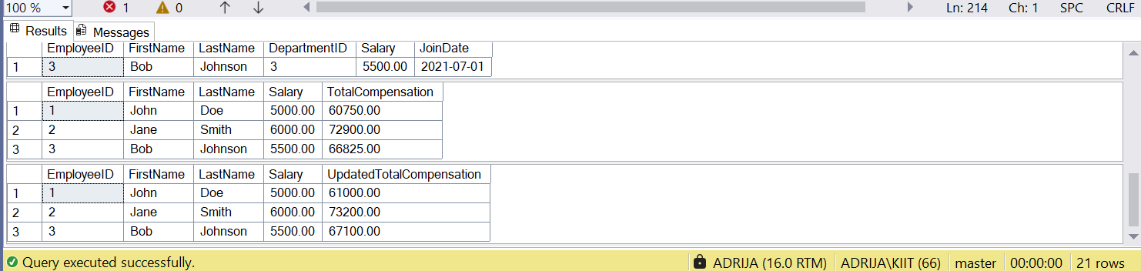

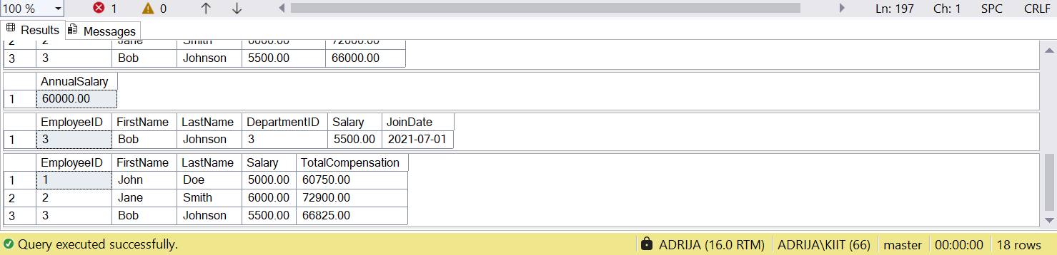

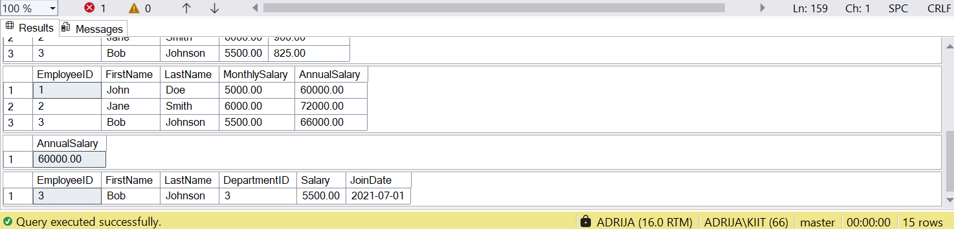

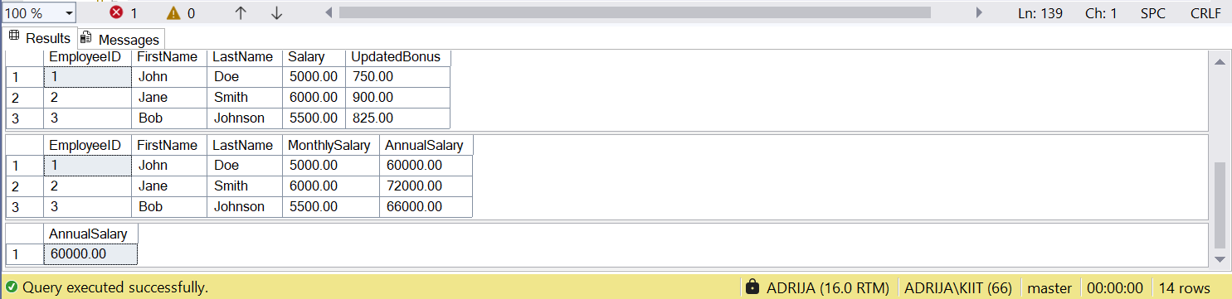

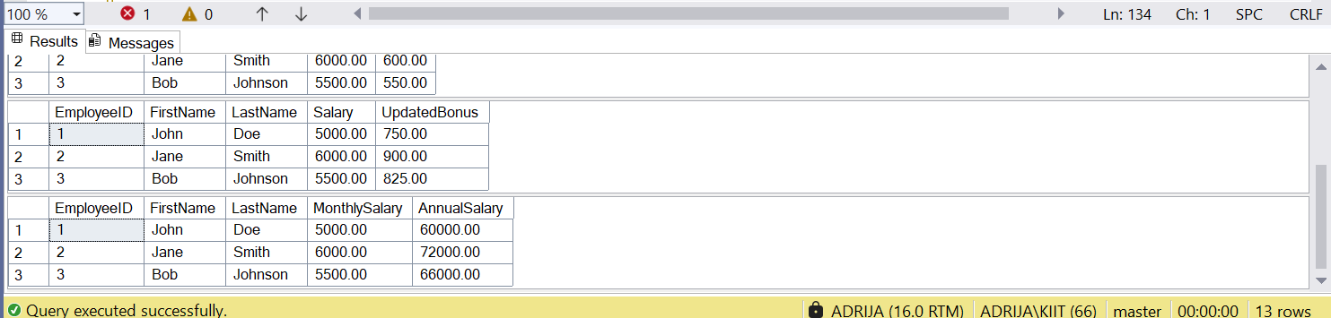

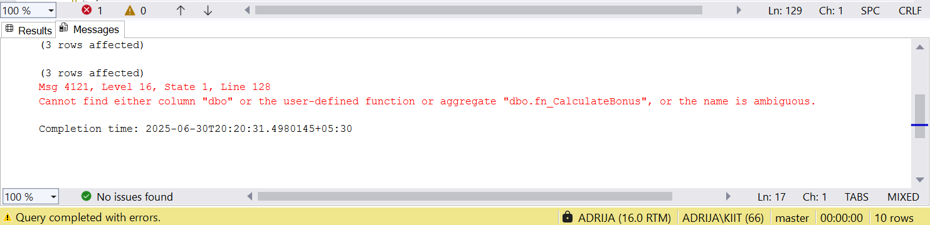

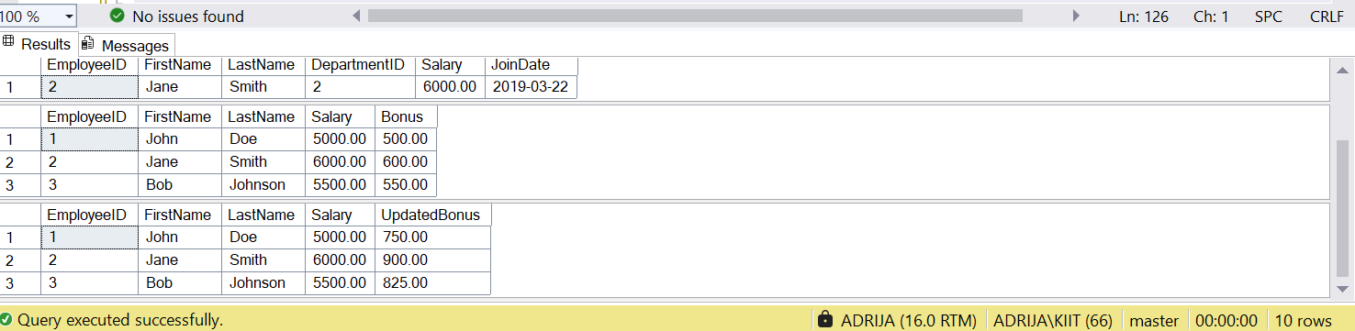

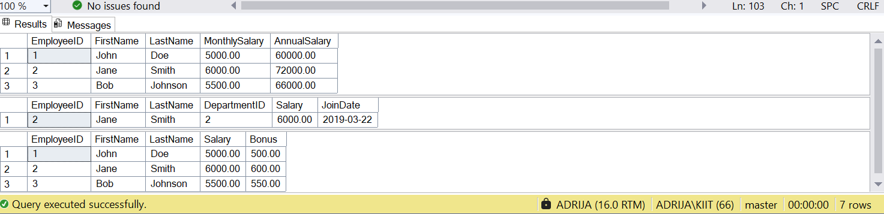

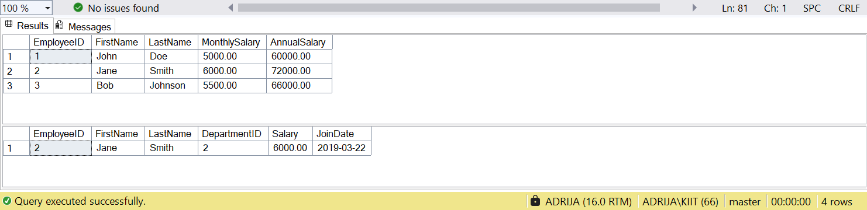

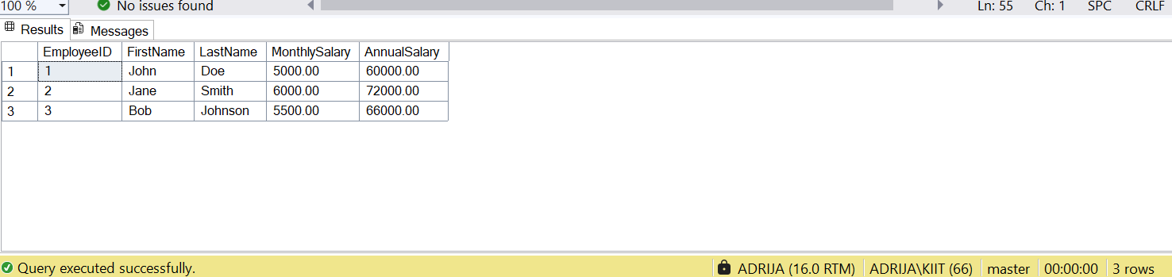

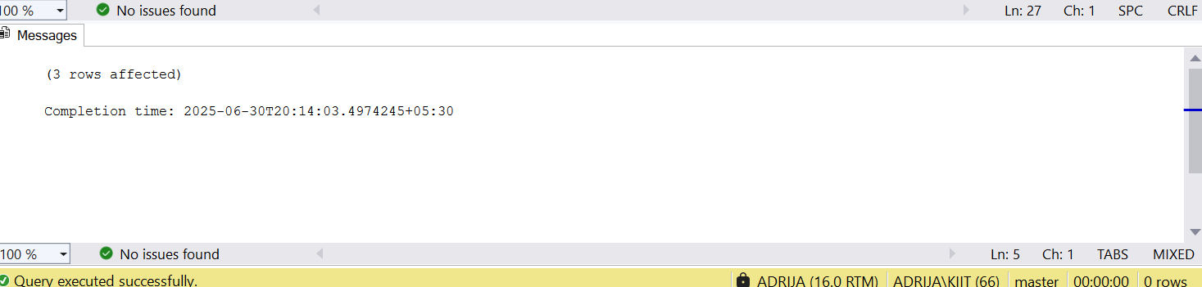

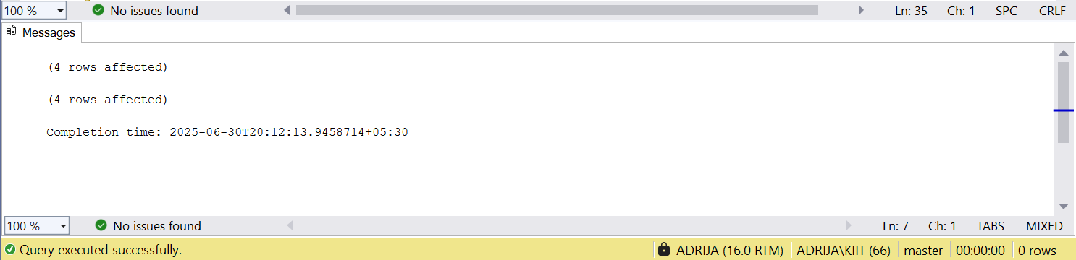

THE DROP QUERY : DROP FUNCTION IF EXISTS fn_CalculateBonus;